

**Artificial Intelligence Project Report**

|  |  |  |  |
| --- | --- | --- | --- |
| Name. | Roll no. | Registration No. | Section |
| Arun Kumar Singh | 59 | 11807845 | K18FG |
| Aditya Dwivedi | 60 | 11802083 | K18FG |
| M Kiran Kumar | 61 | 11810717 | K18FG |
| Bharat Reddy | 62 | 11809752 | K18FG |

**Links-**

**For Github (The Project):**

<https://github.com/kirankumar-M/artificial61.py>

**For YouTube (Video):**

<https://www.youtube.com/wyHw42fY3uc>

**Introduction**

Topic : College Enquiry Chatbot

A Chatbot is a computer program that simulates human conversation through voice commands or text chat or both, shorter form for Chaterbot is chatbot.It is an Artificial Intelligence feature that can be embedded and used through any measure messeging applications.It is a service provided by rules and some artificial intelligence that you can interact with via a chat interface.It uses natural language processing to understand what a human wants an guides and it is a virtual adviser or consultant or assistant to help humans in real time internet user.

**Description:**

First of all in the code we take the input from the user about what news he/she enquires about the college and the computer gives the instructions to the user.

**Then in the Module 1:**

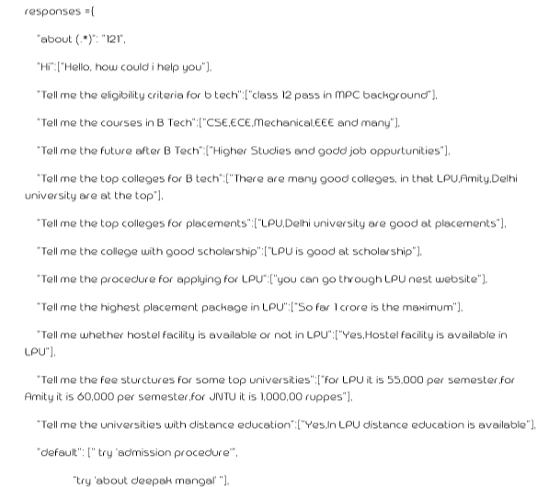

**-In this module the user ask the queries to resolve their doubts about the colleges which he needs to choose ,so the computer gives the major best guidance to the user to help him to choose the college.In this we are given the perfect figures of user question answer commands.The user ask the question and the computer displays the answer.**

**Then in Module 2 :**

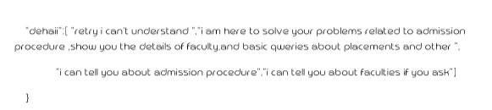

**It gives the best interaction with the user.If the questions are not matched with the database then it diplaysb the default message from the computer side i.e.,”I Cant understand”.It works on the natural processing language even though it cant detects similar mistakes or syntac mistake in the question it cant display the correct solution.Based on the input from the user the program crosscheck with the above two modules and gives us the output.**

**The code :**

import re

import random

responses ={

"about (.*)": "121",

"Hi":["Hello, how could i help you"],

"Tell me the eligibility criteria for b tech":["class 12 pass in MPC background"],

"Tell me the courses in B Tech":["CSE,ECE,Mechanical,EEE and many"],

"Tell me the future after B Tech":["Higher Studies and godd job oppurtunities"],

"Tell me the top colleges for B tech":["There are many good colleges, in that LPU,Amity,Delhi university are at the top"],

"Tell me the top colleges for placements":["LPU,Delhi university are good at placements"],

"Tell me the college with good scholarship":["LPU is good at scholarship"],

"Tell me the procedure for applying for LPU":["you can go through LPU nest website"],

"Tell me the highest placement package in LPU":["So far 1 crore is the maximum"],

"Tell me whether hostel facility is available or not in LPU":["Yes,Hostel facility is available in LPU"],

"Tell me the fee sturctures for some top universities":["for LPU it is 55,000 per semester,for Amity it is 60,000 per semester,for JNTU it is 1,000,00 ruppes"],

"Tell me the universities with distance education":["Yes,In LPU distance education is available"],

"default": [" try 'admission procedure'",

"try 'about deepak mangal' "],

"dehaii":[ "retry i can't understand ","i am here to solve your problems related to admission procedure ,show you the details of faculty,and basic qweries about placements and other ",

"i can tell you about admission procedure","i can tell you about faculties if you ask"]

}

bot_template = "BOT : {0}"

user_template = "USER : "#"USER : {0}"

def sql_responce():

#responce by kshitij after searching in sql data base

return "about the faculty"

f=0

def respond(message):

# Check if the message is in the responses

global f

if message in responses:

f=0

if responses[message]=="121":

bot_message = sql_responce(meshisage)

else:

# Return the matching message

bot_message = random.choice(responses[message])

else:

# Return the "default" message

if f<=4:

bot_message = random.choice(responses["dehaii"])

f=f+1

else:

bot_message = random.choice(responses["default"])

return bot_message

def send_message(message):

# Get the bot's response to the message

response = respond(message)

# Print the bot template including the bot's response.

print(bot_template.format(response))

message =""

while message != "byy":

# Print user_template including the user_message

print(user_template,end="")

message=input()

send_message(message)

**The output :**

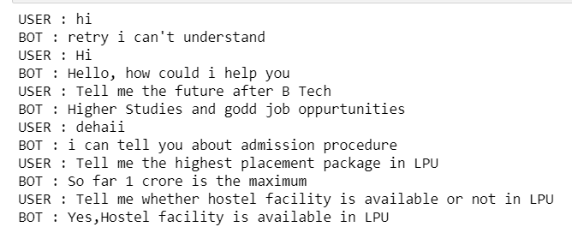

**Work Division:**

This project is divided into some basic modules. Each of our team member has contributed well enough for the accomplishment of the project.

Everyone has contributed towards completion of all the two modules.

Every member of the group has had some input throughout the whole time period during the completion of the project.

**Conclusion:**

The project was completed smoothly with help of everyone.

The program can conclude What the user require to clarify their queries about the colleges.It helps to resolve and guide them.